5.61 Main Question (สำหรับแสดงข้อสอบ)

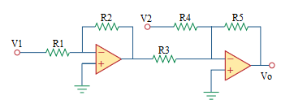

Given *V1* = 1 V, *V2* = 2 V

*R*1 = 10,000 Ω, *R*2 = 20,000 Ω, *R*3 = 20,000 Ω, *R*4 = 10,000 Ω, *R*5 = 40,000 Ω

Find

Variables (สำหรับเขียนโค้ดเพื่อหาคำตอบ)

Random variables

V1 = {1:10};

V2 = {1:10};

R1 = {10000:100000:10000};

R2 = {10000:100000:10000};

R3 = {10000:100000:10000};

R4 = {10000:100000:10000};

R5 = {10000:100000:10000};

Global variables

#V1 = 1; V2 = 2;

#R1 = 10000; R2 = 20000; R3 = 20000; R4 = 10000; R5 = 40000;

VOUT = -(R5/R4)\*V2-(R5/R3)\*(-R2/R1\*V1);

Part (กรอกคำตอบ)

1. Vout = VOUT = -4 V

5.65 Main Question (สำหรับแสดงข้อสอบ)

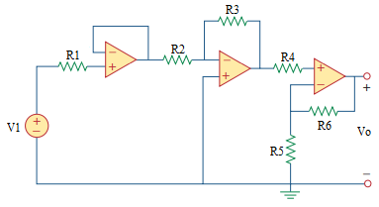

Given *V1* = 10 V

*R*1 = 50,000 Ω, *R*2 = 10,000 Ω, *R*3 = 30,000 Ω, *R*4 = 20,000 Ω, *R*5 = 40,000 Ω, *R*6 = 8,000 Ω

Find

Variables (สำหรับเขียนโค้ดเพื่อหาคำตอบ)

Random variables

V1 = {1:10};

R1 = {1000:100000:1000};

R2 = {1000:100000:1000};

R3 = {1000:100000:1000};

R4 = {1000:100000:1000};

R5 = {1000:100000:1000};

R6 = {1000:100000:1000};

Global variables

#V1 = 1;

#R1 = 50000; R2 = 10000; R3 = 30000; R4 = 20000; R5 = 40000; R6 = 8000;

VOUT = (-(R3/R2)\*V1\*(R5+R6))/R5;

Part (กรอกคำตอบ)

1. Vout = VOUT = -3.6 V

5.67 Main Question (สำหรับแสดงข้อสอบ)

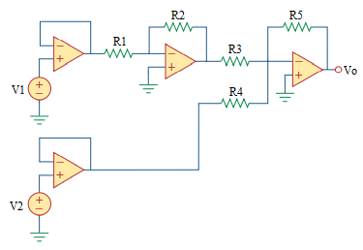

Given V1 = 1, V2 = 2

*R*1 = 20,000 Ω, *R*2 = 80,000 Ω, *R*3 = 40,000 Ω, *R*4 = 20,000 Ω, *R*5 = 80,000 Ω

Find

Variables (สำหรับเขียนโค้ดเพื่อหาคำตอบ)

Random variables

V1 = {1:10};

V2 = {1:10};

R1 = {1000:100000:1000};

R2 = {1000:100000:1000};

R3 = {1000:100000:1000};

R4 = {1000:100000:1000};

R5 = {1000:100000:1000};

Global variables

#V1 = 1; V2 = 2;

#R1 = 20000; R2 = 80000; R3 = 40000; R4 = 20000; R5 = 80000;

VOUT = -(R5/R3)\*(-R2/R1)\*V1-(R5/R4)\*V2;

Part (กรอกคำตอบ)

1. Vout = VOUT = 0 V

5.69 Main Question (สำหรับแสดงข้อสอบ)

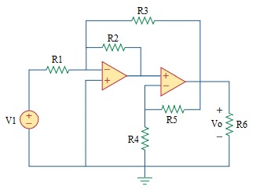

Given *V1* = 10 V

*R*1 = 5,000 Ω, *R*2 = 15,000 Ω, *R*3 = 10,000 Ω, *R*4 = 2,000 Ω, *R*5 = 6,000 Ω, *R*6 = 1,000 Ω

Find

Variables (สำหรับเขียนโค้ดเพื่อหาคำตอบ)

Random variables

V1 = {1:10};

R1 = {1000:100000:1000};

R2 = {1000:100000:1000};

R3 = {1000:100000:1000};

R4 = {1000:100000:1000};

R5 = {1000:100000:1000};

R6 = {1000:100000:1000};

Global variables

#V1 = 10;

#R1 = 5000; R2 = 15000; R3 = 10000; R4 = 2000; R5 = 6000; R6 = 1000;

VOUT = (1+(R5/R4))\*(-R2/R1)\*V1/(1-(1+(R5/R4))\*(-R2/R3));

Part (กรอกคำตอบ)

1. Vout = VOUT = -17.1429 V

5.71 Main Question (สำหรับแสดงข้อสอบ)

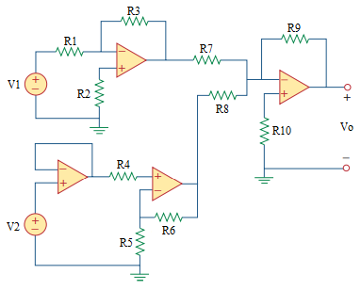

Given V1 = 1, V2 = 2

*R*1 = 5,000 Ω, *R*2 = 10,000 Ω, *R*3 = 20,000 Ω, *R*4 = 10,000 Ω, *R*5 = 30,000 Ω

*R*6 = 50,000 Ω, *R*7 = 40,000 Ω, *R*8 = 80,000 Ω, *R*9 = 100,000 Ω, *R*10 = 20,000 Ω.

Find

Variables (สำหรับเขียนโค้ดเพื่อหาคำตอบ)

Random variables

V1 = {1:10};

V2 = {1:10};

R1 = {1000:100000:1000};

R2 = {1000:100000:1000};

R3 = {1000:100000:1000};

R4 = {1000:100000:1000};

R5 = {1000:100000:1000};

R6 = {1000:100000:1000};

R7 = {1000:100000:1000};

R8 = {1000:100000:1000};

R9 = {1000:100000:1000};

R10 = {1000:100000:1000};

Global variables

#V1 = 1; V2 = 2;

#R1 = 5000; R2 = 10000; R3 = 20000; R4 = 10000; R5 = 30000;

R6 = 50000; R7 = 40000; R8 = 80000; R9 = 100000; R10 = 20000;

VOUT = -(R9/R7\*(-R3/R1\*V1)+R9/R8\*(1+R6/R5)\*V2);

Part (กรอกคำตอบ)

1. Vout = VOUT = 3.333 V